Cisco Lab Practical 8

Objective of this practical exercise: To allow student to have hands-on practice of VLAN configuration for router and switch. In addition, the student will also able to understand the communication between host and network devices. After the tutorial, the students should be able to have a basic knowledge of inter-vlan routing.

Step 1: Study the word document “Configuring VLAN”

Step 1: Construct the network topology below:

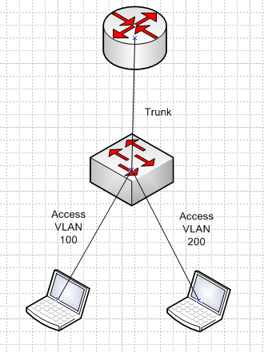

Step 2: Perform the configuration below:

Note: the configuration above is not complete. You are required to change the “xxx” with the configuration you learnt from the word document. You can change any IP addresses if you want.

|  |  |
| --- | --- |
| Router A | interface FastEthernet0/0  description --- Router A--  no ip address  interface FastEthernet0/0.100  encapsuration dot1q 100  ip address 169.192.12.129 255.255.255.192  interface FastEthernet0/0.200  encapsuration dot1q 100  ip address 169.192.13.129 255.255.255.192 |
| Switch | interface FastEthernet0/1  switchport access vlan 100    interface FastEthernet0/2  switchport access vlan 200  interface FastEthernet0/24  description --- Connection to Router A port FE0/0 ---  switchport mode trunk  interface Vlan101  ip address 169.162.12.129 255.255.255.192 |
| Host 1 | ip address: 169.162.12.150  Subnet Mask: 255.255.255.192  Default Gateway: 169.192.12.129 |
| Host 2 | ip address: 169.162.13.151  Subnet Mask: 255.255.255.192  Default Gateway: 169.192.13.129 |

Step 3:

Test 1: From host 1, ping the router 1 & router 2 interfaces.

Yes, it can be done successfully.

Test 2: From host 2, ping host 2. Can you perform the tests above successfully? If not, what are missing? If not again, consult the lab assistant.

Yes, it can be done successfully.